# DATA VISUALIZATION

Number Of Brand Channel

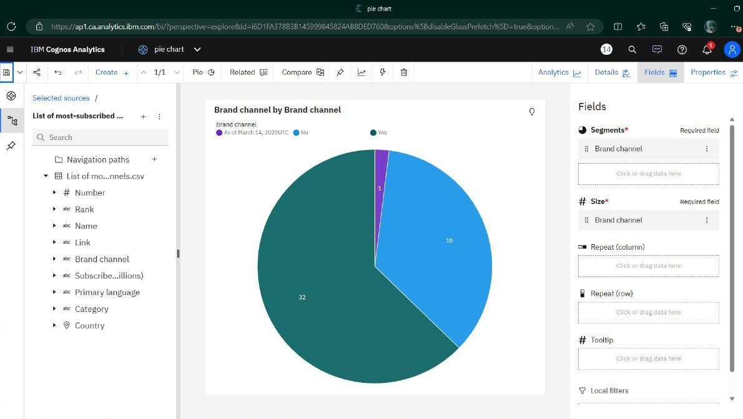

Number Of Subscribers For Primary Launguage

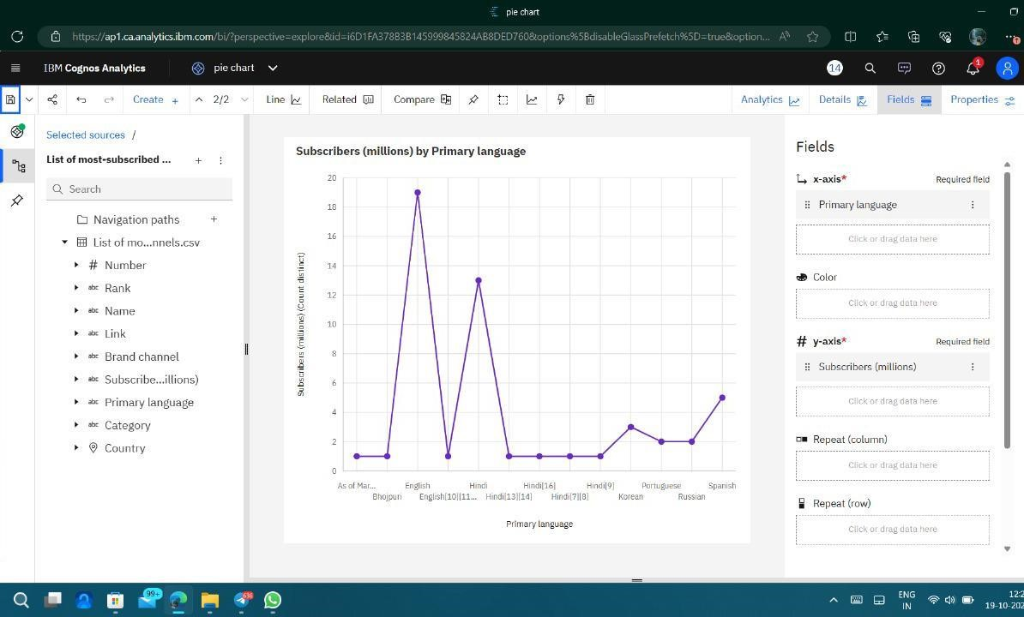

Number Of Subscribers In A Category

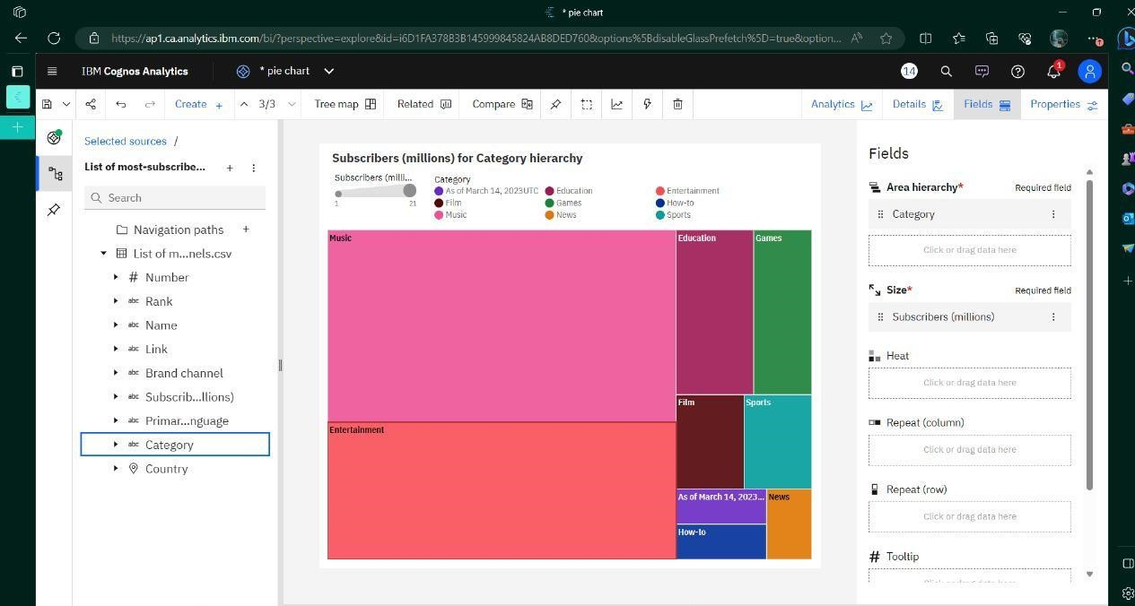

Number Of Subscribers In A Contries With Most Number Of

Subscribers With Specific Language

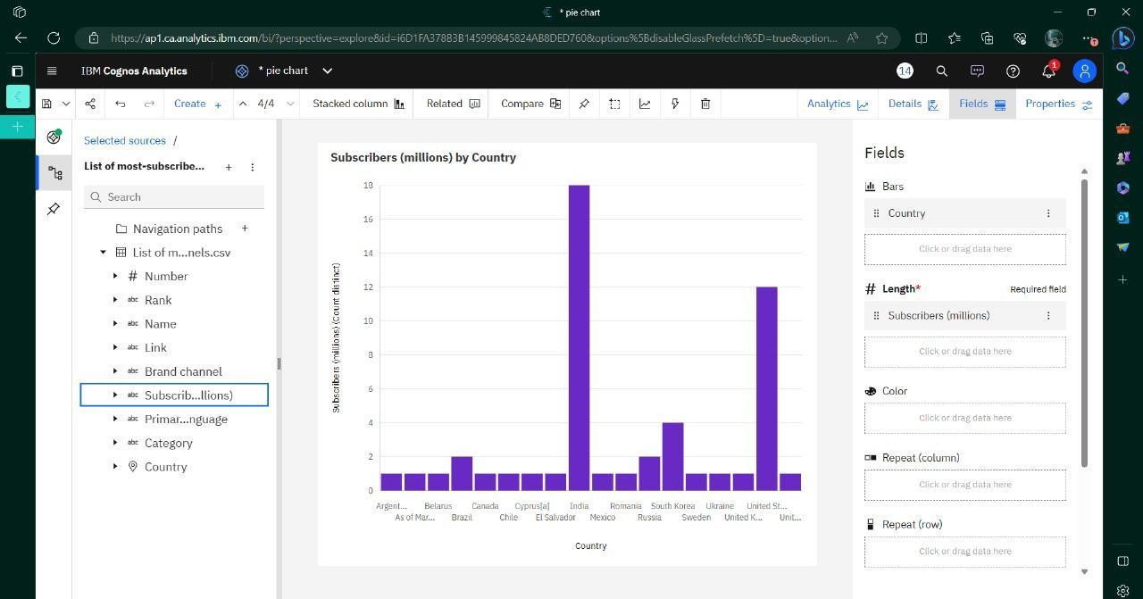

Top 10 Countries With Most Number Of Subscribers With Channel

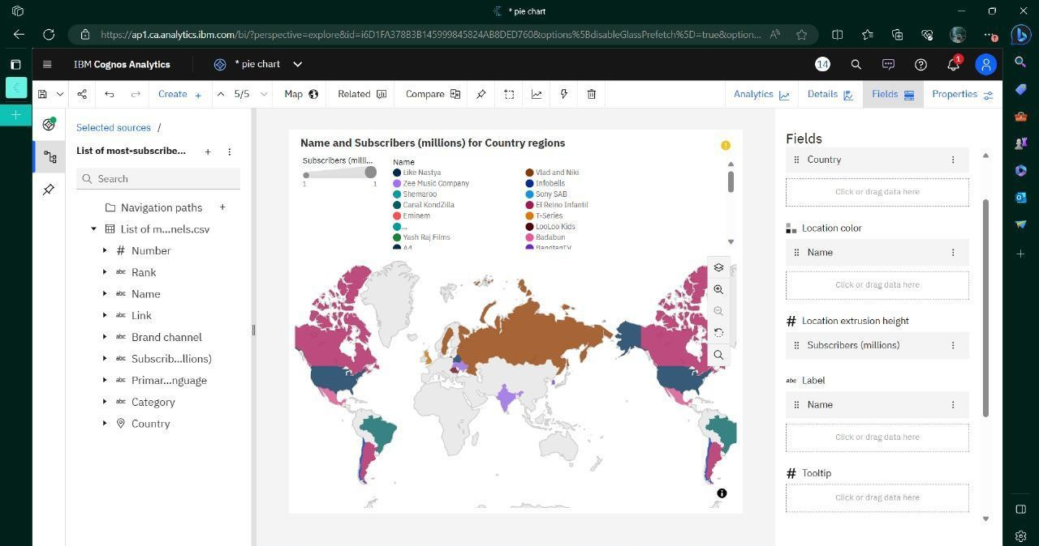

Number Of Subscribers With Language Specified With Brand Channel

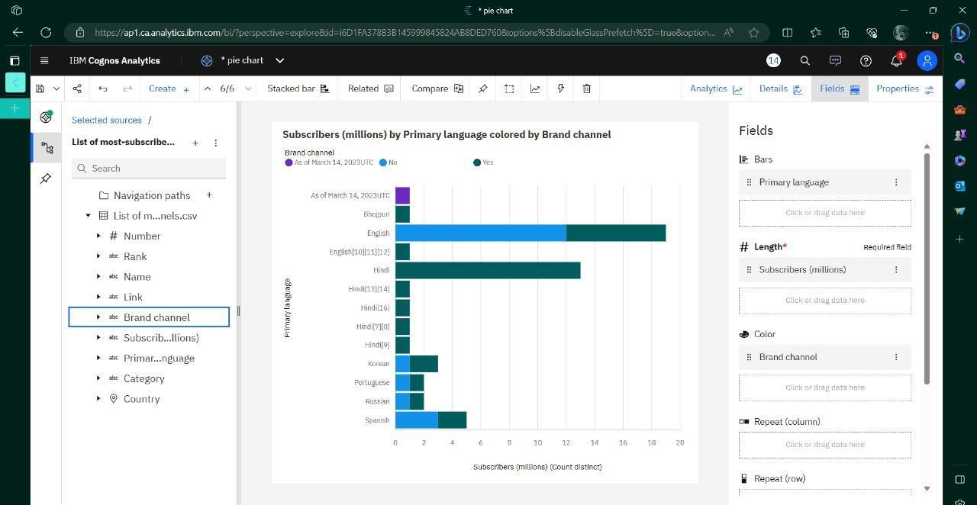

Number Of Subscribers With Language Specified With Category

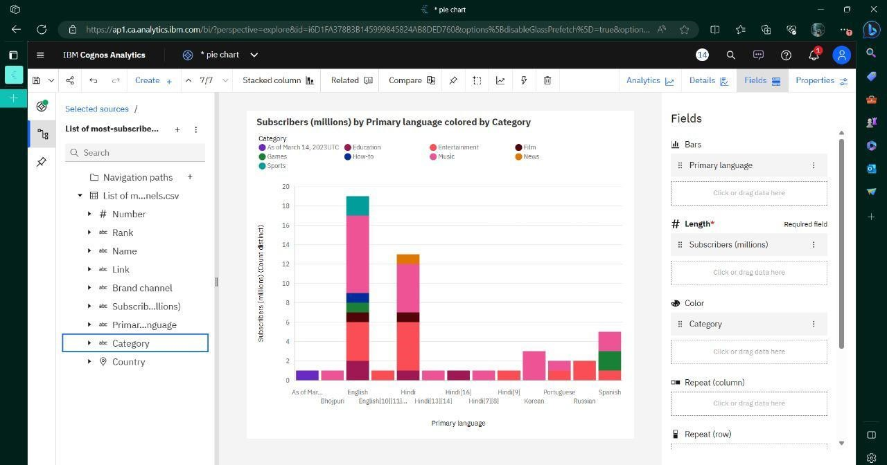

Countries With More Number Of Brand Channels

